Research Area Information:
Computer Science
Which aspects of your academic background do you believe best demonstrate your preparation for this research area? Examples may include, but are not limited to: courses completed, independent study, test scores, etc.
- AP Computer Science A - 4
- Coursera Machine Learning - current 100% score in quiz
- Pre-IB Math - 7
- HL Math Analytics and Approaches - midterm 6
- Physics Bowl - National Silver
- Pre-IB Physics - 6
- HL Physics - midterm 7
- Pre-IB Chemistry – 6
- Self-Study: Python, linear algebra, AP Calculus BC
Do you have any other experience or qualifications in this field? Tell us anything about your background that may be helpful in demonstrating your interest in this specific subject area. (100 words)

I was introduced to programming in Grade 1 where I created a game with Scratch about navigating around obstacles. This experience introduced me to technology, which I fully embraced. In middle school I further engaged by joining computer science clubs and designing self-navigating cars. Furthermore, I completed the Yale Advanced Pre-College Program, studying STEM and attended the GirlzTechIn Summer Camp at Microsoft. Moreover, I volunteered at Stepping Stones non-profit to design a course for beginners of Java and taught middle-school students about Java. The courseware was transferred to Stepping Stones to enhance their teaching activities.
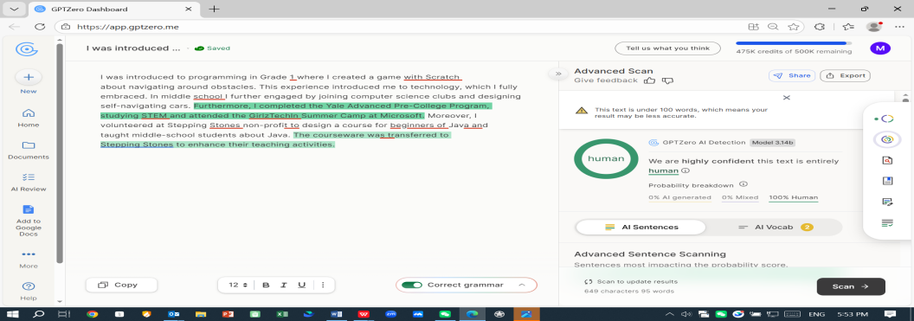

Pioneer considers both your specific interests and broad intellectual curiosity within each research area. Please tell us why you want to engage in this research area, clarifying your openness to exploring beyond the interests you describe (100 words minimum, 150 words maximum).
I believe that mastering computer science is key to understanding the functioning of our dynamic world. Technologies act as the cornerstone of human optimization.
When I taught middle school students at Stepping Stones non-profit, I could see their desire to understand technology; yet, they did not have access to resources. And in today’s dynamic world, technical expertise is necessary to integrate into modern society. As such, I have become involved in teaching these kids coding as well as leveraging AI to help them. I realize that even though technologies such as AI are prevalent, the ways to access information for migrant children still remain limited and problematic. This may create substantial shortcomings for those children in their school life. Therefore, by actively participating in research about computer science, I wish to better prepare myself to build a bridge between underprivileged people and knowledge.
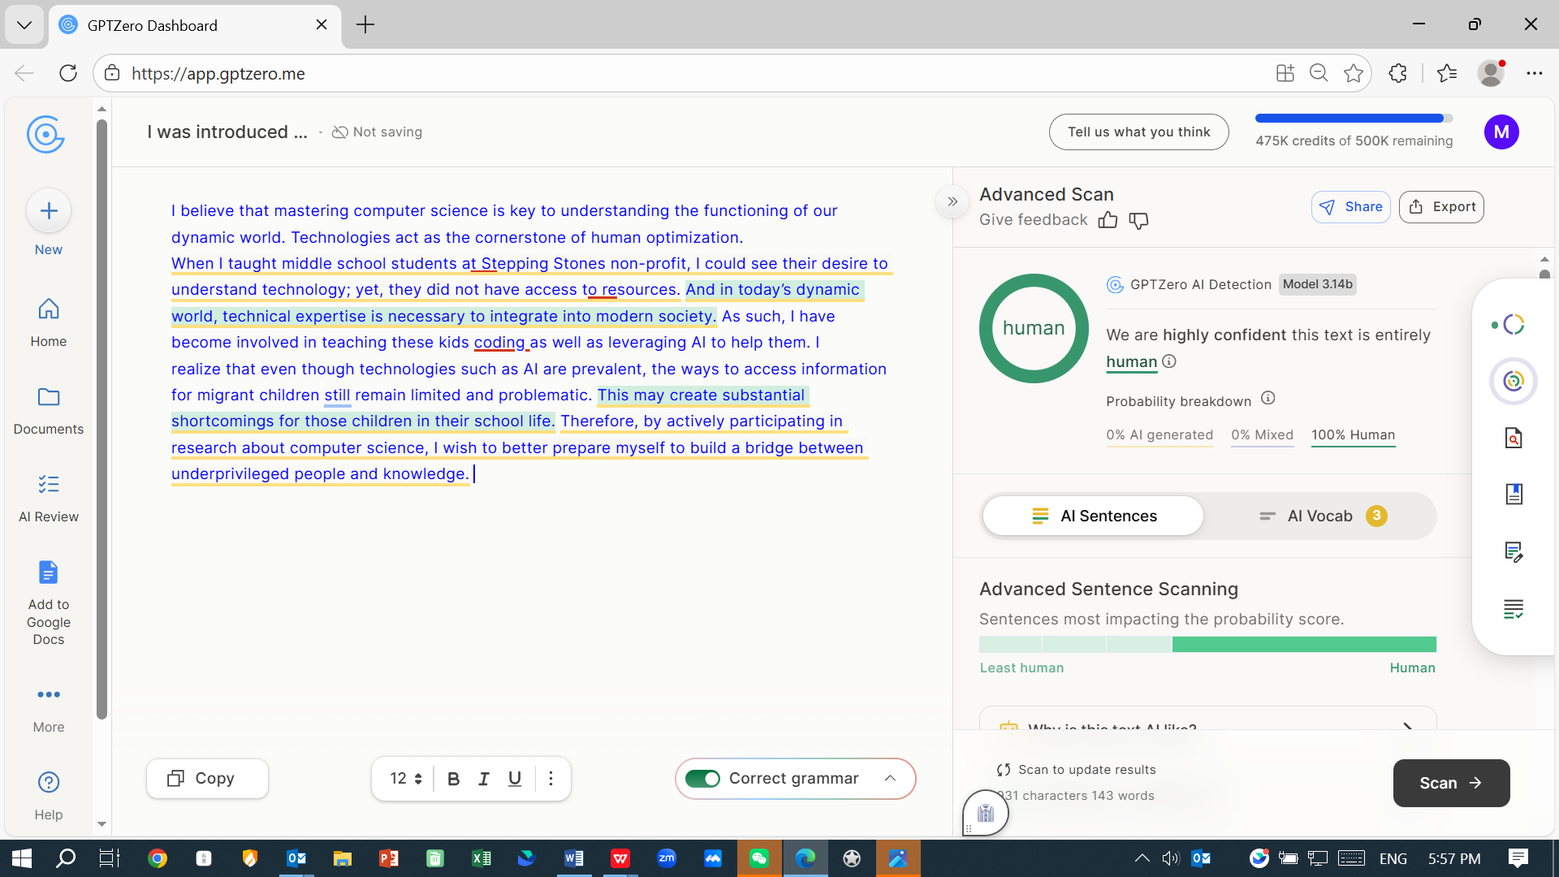
- Engineering
Which aspects of your academic background do you believe best demonstrate your preparation for this research area? Examples may include, but are not limited to: courses completed, independent study, test scores, etc.
- AP Computer Science A - 4
- Coursera Machine Learning - current 100% score in quiz
- Physics Bowl - National Silver
- Pre-IB Math – 7
- HL Math Analytics and Approaches - midterm 6
- Pre-IB Physics - 6
- HL Physics - midterm 7
- Pre-IB Chemistry 6
- Self-Study: Python, linear algebra, AP Calculus BC
Do you have any other experience or qualifications in this field? Tell us anything about your background that may be helpful in demonstrating your interest in this specific subject area.
I have been studying physics since fourth grade. I have also competed in Physics Bowl (National Silver). In CTB, my group members and I conducted research on mitigating lower back problems encountered by senior citizens during exercise. In order to reduce the problem, we designed a protective belt using multiple barometers. The paper has been included in the 2023-2024 CTB National Youth Research & Innovation Conference Proceedings.
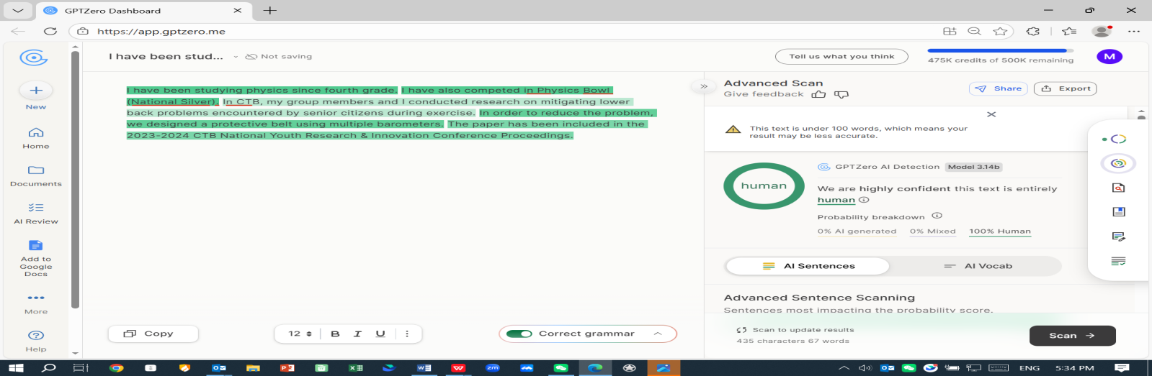

Pioneer considers both your specific interests and broad intellectual curiosity within each research area. Please tell us why you want to engage in this research area, clarifying your openness to exploring beyond the interests you describe (100 words minimum, 150 words maximum).
Engineering intrigues me as I can transfer from blueprint into reality. When participating in CTB, I gained awareness of lower back pain as a hindrance to regular exercise. Thus, I designed a protective belt to protect the back. Yet our team would have benefited from seasoned experience and guidance, along with staged improvements, as our belt did not meet expectations. I learned from this experience that mentorship and gradual refinements would have created a better product. Moreover, I learned that engineering is not about building things from 0 - 1 but about revising in stages. Thus, I look forward to the mentorship of seasoned professors to help me build better products that will help heal lives.
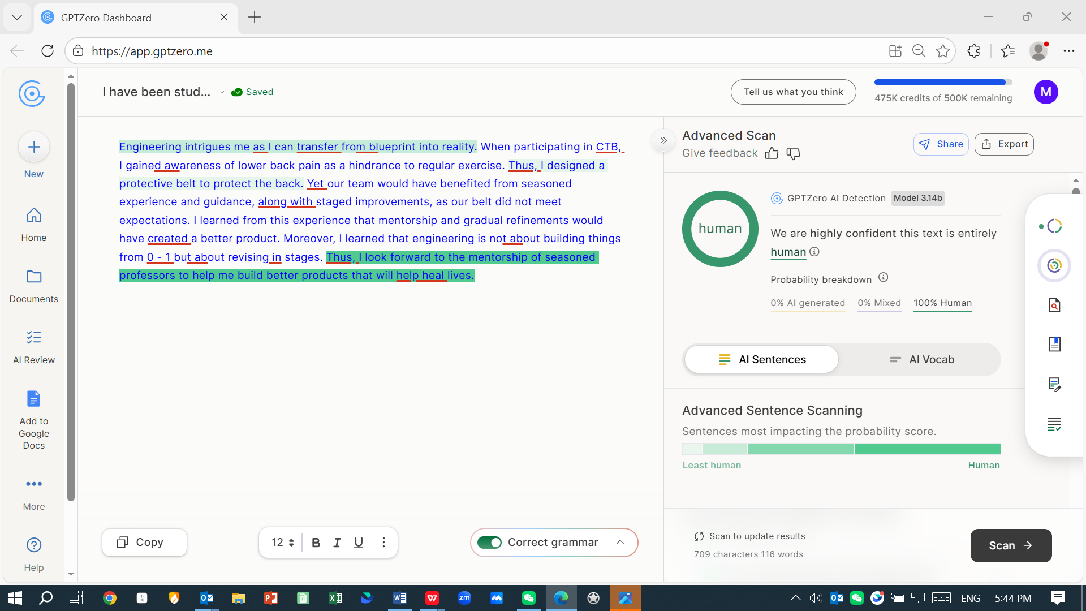

Application essay (required):
“Often the right path is the one that may be hardest for you to follow. But the hard path is also the one that will make you grow as a human being.” – Karen Mueller Coombs
The Pioneer Research Institute is widely recognized as one of the most rigorous and challenging academic opportunities available to high school students. Reflecting on the quote above, discuss how Pioneer's high academic standards will help you reach your full potential and achieve your goals. In your response, please directly reference and engage with the quote above. Clearly explain why you have chosen your academic goals and how specific features of the Pioneer Research Institute will support your growth. We encourage you to incorporate ideas from Pioneer’s website or share insights you’ve gained from others familiar with the Institute. Your response should be between 300 and 400 words (300 words minimum, 400 words maximum). Please note that using AI is not allowed; the prompt and all essays will be checked for AI generation.
355 words
I am confident that taking on new challenges leads to genuine growth. With this belief, I gladly tackle numerous obstacles, continuously pushing myself beyond my comfort zone. In this regard, the “uncomfortable” path has always been my path for personal development. Thus, I appreciate Pioneer's selective and rigorous approach.
Research has always been a demanding route. Unlike math questions, research does not have a set answer. However, I am now willing to forge my own path. As a long-time Edgar Allan Poe fan, I have always been fascinated by the horror effects he created with his words. As a STEM student, I want to train my own model to quantify the word choice of the writer, actively analyzing how his use of words has led to the gothic style in his books. As a result, by participating in Pioneer, I hope to be able to use coding and computer models as useful application tools to interpret and visualize data, in addition to studying it.
With the one-on-one professor tutorial sessions, I will be able to clear my path to tackling engineering or computer science challenges, such as implementing the automatic alarm system in the protective belt I previously built in CTB. In a video posted in the Pioneer Alumni Spotlight, Francisco J. Tezen mentioned that students are able to build on their experiences under guidance. When designing the protective belt, I was responsible for the actualization of the design. Our group placed four barometers at the back of the belt in correspondence with the four vertebrae in the lower back where maturing individuals experience high pressure. The airbags connected to the barometers were compressed, leading to increasing detected pressure upon release. However, due to our group’s lack of knowledge in ergonomics, we were compelled to retrofit our 4 barometers onto pre-existing systems. This led to significant hindrance on the accuracy of our experiment results. By participating in Pioneer, I look forward to furthering my groundwork for my future profession in computer science or engineering. By embarking on this challenging journey, I will be able to fully realize my potential as leveraging technology to heal others.
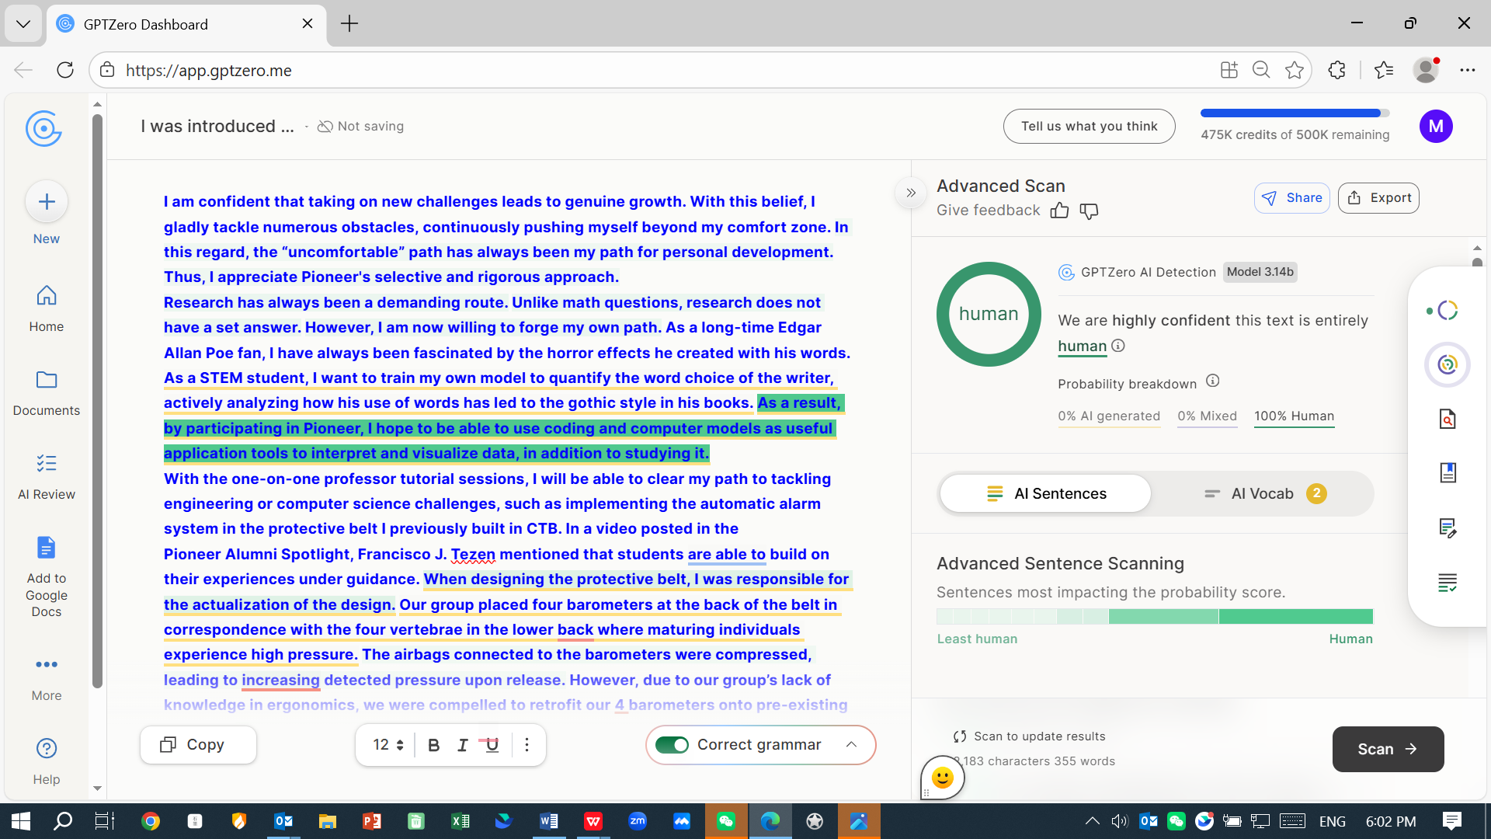

Parking Lot
I strongly believe that actual growth is derived from taking challenges. With this belief, I had willingly faced thousands of challenges, pushing myself repeatedly out of my comfort zone. In this way, the ‘uncomfortable’ path has always been the right path for my growth. Given how selective and rigorous Pioneer is, it is the correct and suitable path that I should take in order to make progress.
Personally, research has always been an exacting path. Opposite from math questions, research do not have a standard answer. However, now I am willing to create my own path. Being a fond reader of Edgar Allan Poe, the horror effects he created through words always amazed me. As a STEM student, I wish to combine the knowledge I have in computer science and my interest in the books of Edgar Allan Poe. Specifically, I am willing to create and train my own model to quantize the word choice of the writer, actively analyzing how his use of words has lead on to the horror effects in his books. Therefore, by participating in Pioneer, I wish to have the opportunity to use coding and computer models not as a research subject, but as a handy tool for me to tackle and visualize data.
With the one-on-one professor tutorial sessions provided, I will be able to clear my path towards solving problems in engineering or computer science, such as realizing the automatic alarm system in the protection belt I previously designed in CTB. In a video made by 23 alumni on Pioneer website, multiple students have mentioned the supportiveness of the professor and cohort students. Therefore, with me being able to talk with college professors, I will be able to receive profound guidance and also be inspired by the ideas from students across the world.
At the same time, Pioneer’s standardized requirements on essays can force me to organize my vague ideas and think of every possible outcome. Specifically, I will be able to forge my fragmented insights I have for the protection belt and build a tangible prototype.
Therefore, by participating in Pioneer, I wish to build the foundation for my future career in computer science or engineering. I believe that by walking on this arduous path, I can fully expand my potential and become a solver of complicated questions.

Please share up to 3 extracurricular activities in which you have participated that you feel are important for us to consider with your application, and describe why they are meaningful to you. 75 words max for each
- I have been a volunteer at Stepping Stones non-profit since ninth grade. There, I have taught Math and Java to migrant kids in China. Additionally, I have designed a sixteen-hour course specifically crafted for Java beginners, teaching a class of eight. The courseware was given to Stepping Stones to enhance the student learning experience so that all kids could be educated.
- The lack of female teams made me realize the reluctance of girls participating in sports and the importance of changing this which is why I founded and led the school’s floorball team. I have organized and led our weekly trainings and coached beginner-level members about the fundamentals. Floorball taught me the importance of taking initiative and cultivating collaboration.
- I am one of the core members of our school’s Phytotherapy Club. Every two weeks, our members go to the local hospital and teach young patients cultural traditions such as traditional Chinese medicine. This activity shows me the importance of serving a community so that they can eventually integrate into modern society. It also made me realize the importance of preserving cultural heritage.
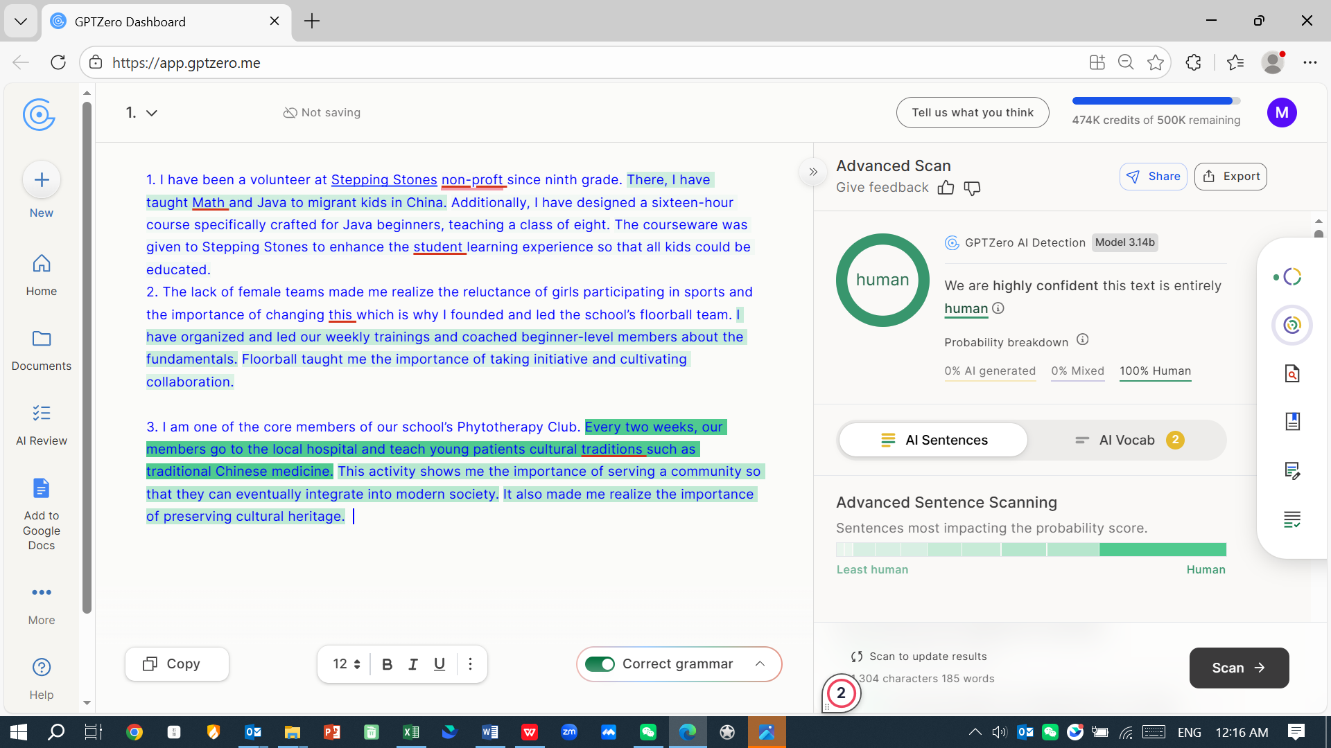
Is there any information not captured in the application that you would like to share with the Admissions Team? If so, please briefly add the information in the space below: (150 words)
I have skipped both fifth and sixth grades in school. Thus, I am the youngest in my class by two years. Being physically smaller and younger than my other classmates has encouraged me to be nimble and quick, working harder and faster compared to the rest so as to ensure that I’m either on par or ahead. Thus, I am resilient and thrive in academically rigorous environments.

